Leah and Tom both have number lines and a counter. They always start with their counters at zero.
Leah's number line goes along from left to right like this:
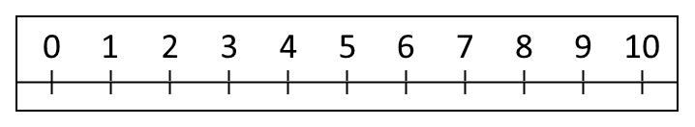
First Leah made a jump of three along her number line and then a jump of four. Where did she land?
Next Leah made a secret jump along her number line. Then she made a jump of five and landed on 9.
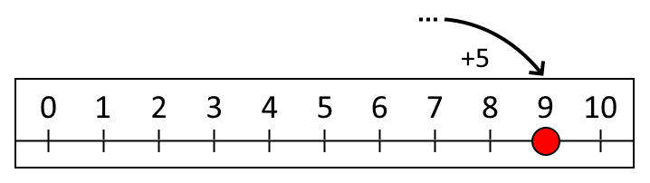
How long was her secret jump?
Then Leah made a jump of six and another secret jump. She landed on 10.
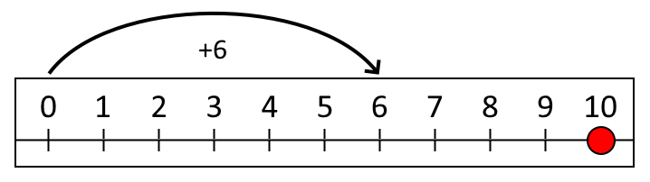
How long was her second secret jump?
Tom's number line goes up and down like this:
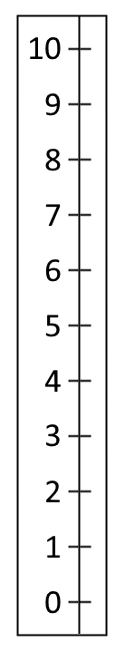
First Tom made a jump of three up his number line and then a jump of two. Where did he land?
Next Tom made a secret jump up his number line. Then he made a jump of six and landed on 8.
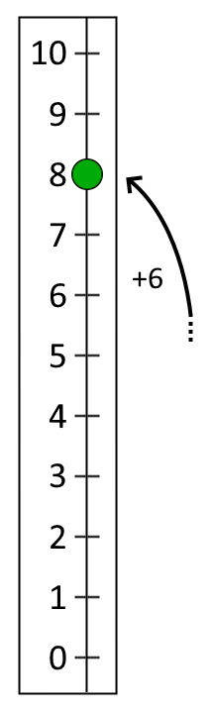
How long was his secret jump?
Then Tom made a jump of four and another secret jump. He landed on 7.
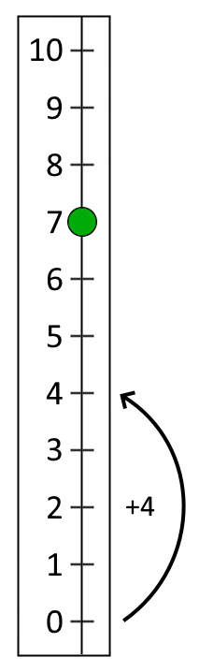
How long was his second secret jump?

